

Practices for Secure Software Report

Table of Contents
Document Revision History 3
Client 3
Instructions 3
Developer 4
1. Algorithm Cipher 4
2. Certificate Generation 4
3. Deploy Cipher 4
4. Secure Communications 4
5. Secondary Testing 4
6. Functional Testing 4
7. Summary 4
8. Industry Standard Best Practices 4

Document Revision History

Version | Date | Author | Comments
1.0 | 10/18/2026 | JOHN GLODY KUBIKULA-VE

Client



Instructions

Submit this completed practices for secure software report. Replace the bracketed text with the relevant information. You must document your process for writing secure communications and refactoring code that complies with software security testing protocols.

- Respond to the steps outlined below and include your findings.
- Respond using your own words. You may also choose to include images or supporting materials. If you include them, make certain to insert them in all the relevant locations in the document.
- Refer to the Project Two Guidelines and Rubric for more detailed instructions about each section of the template.

Developer
JOHN GLODY KUBIKULA-VE MAMBU

Algorithm Cipher

To ensure data security at rest, as well as to verify the integrity of Artemis's data streams, I recommend the use of AES-256 and SHA-256 for checksums used in message and transfer verification. Note that AES is used for encrypting sensitive data.
The choice of SHA-256 was made because I want to avoid any collisions present in old algorithms, such as MD5 and SHA-1. With the unique 256-bit fingerprint produced by SHA-256, any malicious modification or brute force attack is mathematically impossible. It also makes verification strict and reliable, because for the same input, the output remains the same.
Regarding the keys, I have simplified the definitions to keep it straightforward:
* Symmetric: It uses the same key to encrypt and decrypt, and it is used for encrypting large volumes of data.
* Asymmetric: Here, a public key encrypts and a private key decrypts. It is used for the initial exchange and the HTTPS/TLS configuration.
* Random Numbers: Keys must be generated using SecureRandom to prevent any predictability from attackers, as it generates truly random numbers.
In the past, we used DES with 56 bits, but it was highly vulnerable to brute force attacks. Later, we had SHA-1 and MD5, but these are now forbidden because collisions occur frequently. Today, we have AES-256. So far, no one can compromise it, whether through brute force or other means; it is mathematically impossible

Certificate Generation
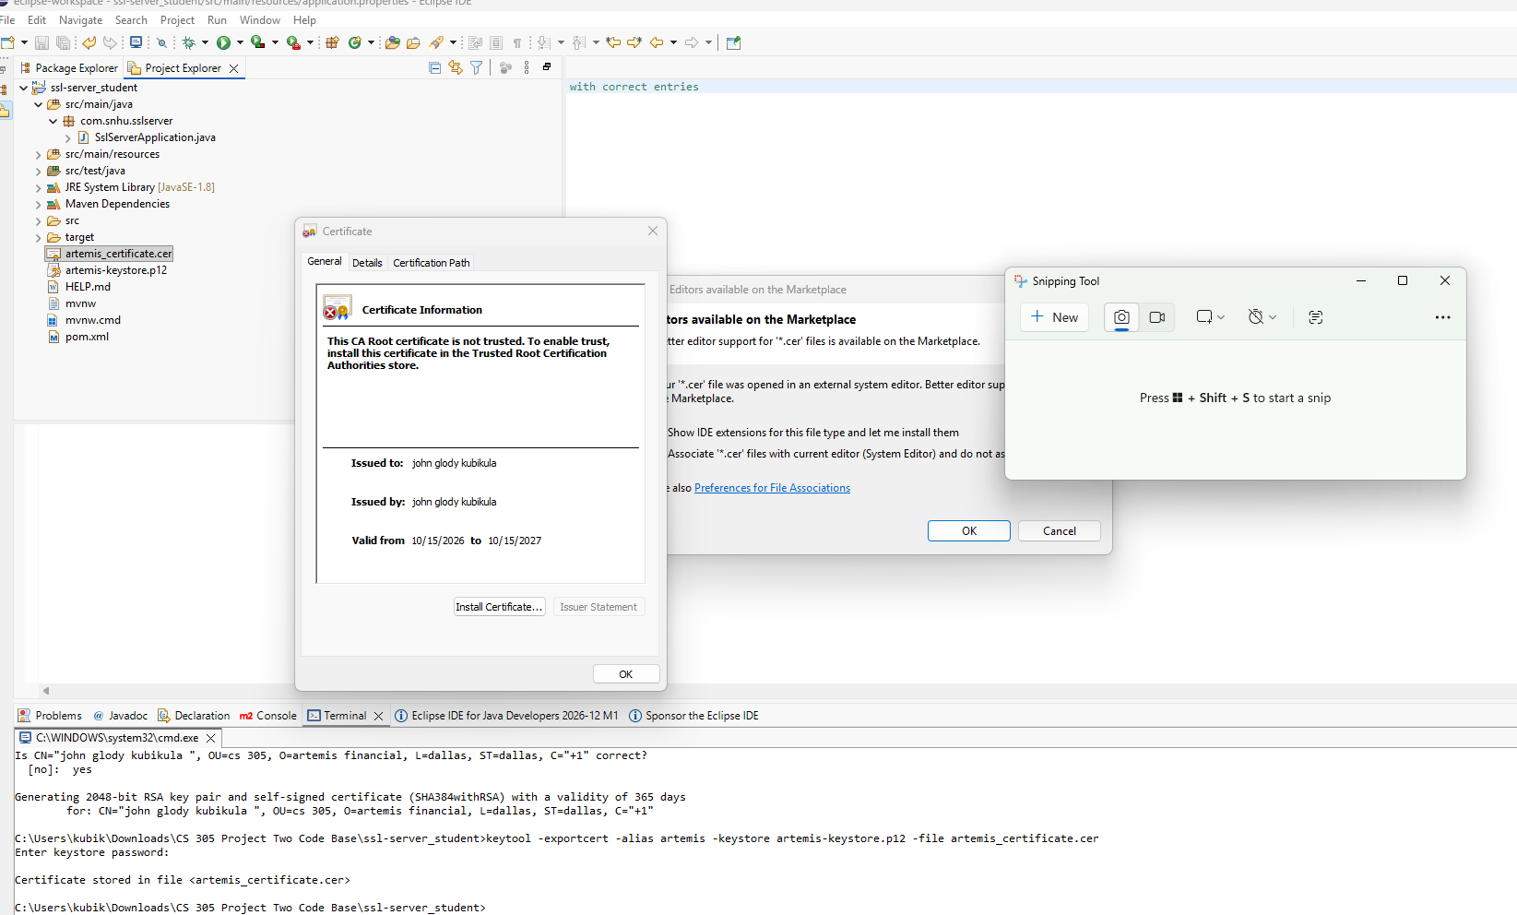

Deploy Cipher
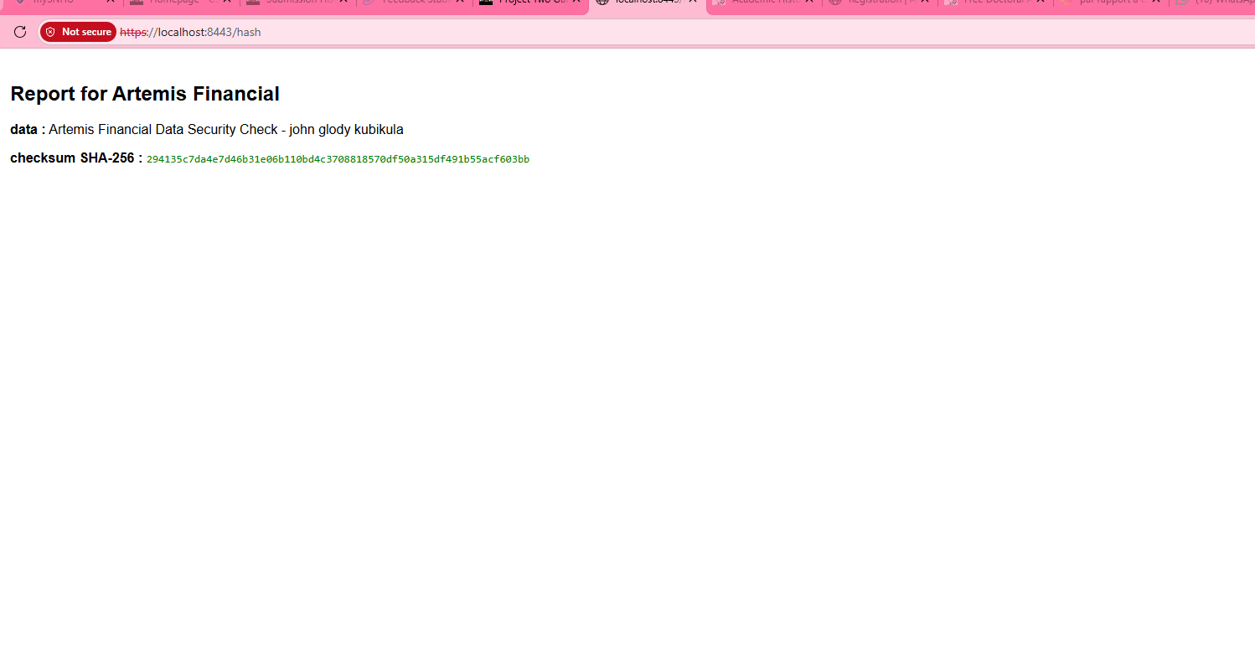

Secure Communications

Secondary Testing

Due to some technical problems I couldn’t generate the dependency report but you can see that the build was successful in the picture I just attached.

Functional Testing
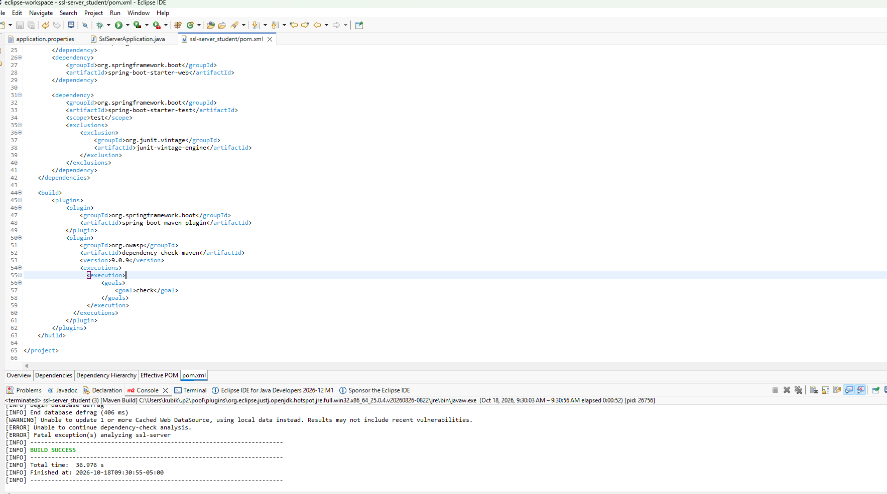

Summary
The code refactoring for Artemis Financial was conducted in strict accordance with the vulnerability assessment flow diagram. I addressed two critical security areas that weakened the initial architecture. First, the transport layer was secured by migrating from the clear-text HTTP protocol to HTTPS via TLS, which effectively blocks any Man-in-the-Middle (MitM) data interceptions. Second, I added an integrity validation layer by implementing SHA-256, guaranteeing that the financial data streams undergo no malicious modifications.

Industry Standard Best Practices

To mitigate long-term technological risks, the application of industry standards based on OWASP recommendations, as well as the strict requirements of the finance sector, is essential.
By treating test code and static analysis reports—such as Dependency-Check—with the same rigor as production code, Artemis Financial prevents the accumulation of technical debt and the obsolescence of its dependencies.
For the company, secure coding provides the most essential added value. It protects the confidentiality of client data, preserves the company's reputation, and above all, guarantees full compliance with banking and privacy regulations.

